Welcome to Year 5 2021-22

Year Group Team

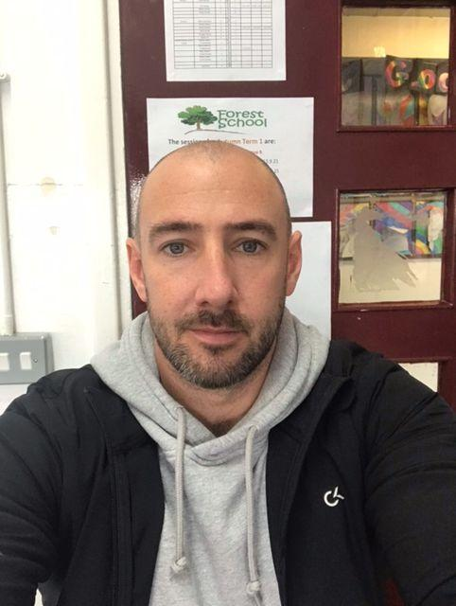 | Mr Hints  Cedar Class Teacher | 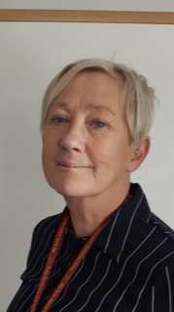 | Mrs Pooke  Learning Support/ Assistant SENCO
 | Mrs Moriarty  Birch Class Teacher  (Mon- Wed am) | 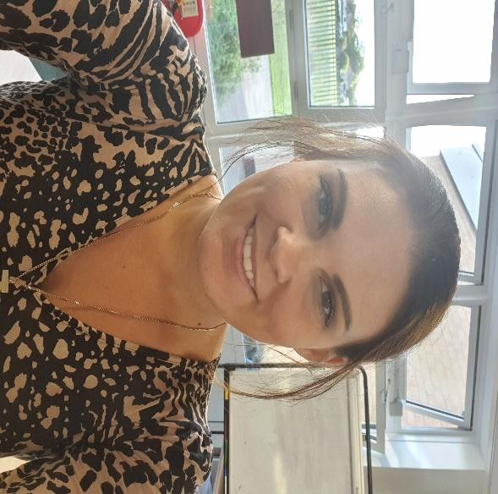 | Mrs Selby  Birch Class Teacher  (Wed pm- Fri)
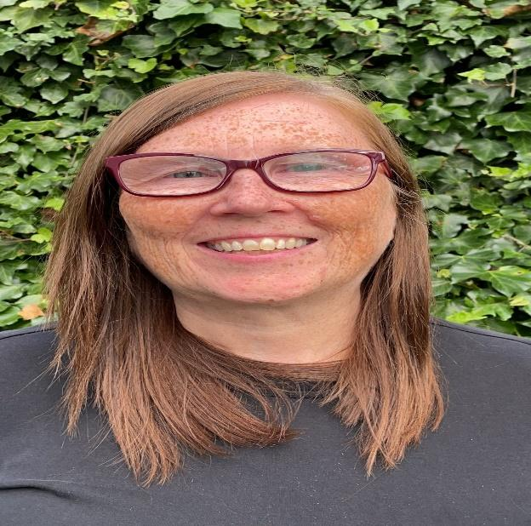 | Mrs Newstead  Forest School |  | Mr Brady  Sports Coach

Welcome to Year 5

Welcome to Year 5! This welcome pack provides information for parents and carers that you may find useful this year. We are delighted to be working with you and your children over the next academic year. May we take this time to thank you for your ongoing support and patience, as we still adjust to school life living with some COVID restrictions. We would like to take this opportunity to let you know how well the children have started the year. As always they have made us proud with their positive approach to school life.

Working together
Twitter: @CTKLiverpoolY5
If you want to feel closer to the classroom, please follow our Year 5 Twitter page to see what is going on in our school community. We would like to remind you that we do not respond to DM’s on Twitter so if you have any questions to ask us, the best way to do so is to either contact the school office, speak to us at the door or, if it isn’t an immediately pressing issue, leave a note with child for us to see. We will be sharing lots of the wonderful moments that the school day brings so please take a look.
Lost Property:
It is important that the children are to become more responsible for their own possessions, such as their jumpers/cardigans, coats, water bottles and lunch boxes. So far this year, we have noticed that a lot of children are leaving their things behind them after break times or lunches. This can cause a lot of wasted lesson time and is a burden on parents/guardians who have to replace these things. We will work hard in school to impress this attitude upon the children, so we would greatly appreciate it if this was also promoted at home. Additionally, we recommend that you write the name of your child on their labels of clothes to identify who owns what.
End of school day:
Please ensure your child knows who is picking them up at the end of each day. If you would like them to walk home or to the school gate you must have responded to the notification on the app or have spoken to the class teacher. If your child is to be picked up by somebody else’s parents in the class or somebody not on their list can you please tell the class teacher. Children will not be allowed to leave until official confirmation has been given by parents. We also ask for parents not to engage with their child in class through the windows at the end of the school day. Our day finishes at 3.15pm (5 minutes after KS1). All of this is for the safety of your child and to ensure that no safeguarding issues arise at the end of each school day as it can be extremely hectic at times.
Please use our school app to look for letters and messages daily as we seek to promote a safer and more environmentally friendly approach to communicate.

Important things for Y5

PGL: Wednesday 23rd March – Friday 25th March. More information will follow during the school year.
Clubs: Check app every half term – They are usually first come, first served due to a lot of interest.
Assessments: No statutory assessments this year. Assessment weeks will take place periodically throughout the school year.

What will we be learning this year?

 | Autumn 1 | Autumn 2 | Spring 1 | Spring 2 | Summer 1 | Summer 2
Come and See RE | Ourselves  Life Choices | Baptism/ Confirmation  Advent | Community  Eucharist | Eucharist  Islam  Lent/ Easter | Pentecost  Reconciliation | Reconciliation  Universal Church
English | Oliver Twist  Persuasion/  Older Literature | Tuesday  Novels and Stories by Significant Authors/  Recounts/  Poetry | Journey to Jo’burg  Stories from Other Cultures/  Narrative Poems | This rock That rock(poems between you me and the moon)  Dramatic Conventions/  Performance poetry | Beowulf  Legends/  Choral Poetry | Thomas Edison’s Biography  Instructions
Maths | Place Value  Addition and Subtraction  Multiplication and Division | Word Problems  Graphs  Fractions  Decimals | Percentages  Geometry  Position and Movement | Measurement  Area and Perimeter | Volume  Roman Numerals | Revision
Art & Design | Landscapes | - | Silhouettes | - | Collage/Printing | -
Computing | Digital Mapping | Internet safety  Research | We Are Artists! | Multi Media Animation and Sound | Coding | Coding
Design Technology | - | Designing A Christmas Stocking | - | Making Rocket cakes | - | Electrical Circuits
Geography | - | Place Knowledge | - | Locational Knowledge | - | Human and Physical Geography
History | Victorians | - | Nelson Mandela | - | Anglo Saxons | -
Music | Play and perform in solo and ensemble contexts, using their voices and playing musical instruments with increasing accuracy, fluency, control and expression | Improvise and compose | listen and recall sounds with increasing aural memory | Use and understand staff and other musical notations | Appreciate and understand different traditions, composers and musicians | Develop an understanding of the history of music
Physical Education | Fitness  Dodgeball | Gymnastics  OAA | Swimming  Basketball | Swimming  Athletics | Dance  Netball | Leadership  Danish Long ball
PSHE | Get Heart Smart | Don’t Forget to Let Love In | Don’t Rub It In Rub It Out | Too Much Selfie Isn’t Healthy | Fake Is A Mistake | “No Way Through”  Isn’t True
Science | Plants | Living Things and Habitats | Materials | Space | Forces | Electricity

PE & Forest School

See regular updates on the website and app for PE and Forest School days.
2 lessons per week- one with class teacher and other with Mr Brady.
Children will have a timetabled session of outdoor learning on alternating weeks.
Children are to attend school in school tracksuits.
Please bring wellies/waterproofs if it will be raining.

Homework & Reading

Paper copies of homework will go home on Fridays. There will be spellings to practise and a short Maths task to complete. Homework can be brought in any day during the week, but must be completed and handed in by Friday at the latest, as this is when we will check it in class and spellings will be tested.

We are also asking your child to spend time on Times Tables Rock Stars and Reading Plus. Reading should be equivalent to 10 minutes per school night, or you can complete it at the weekend, equating to a minimum of 60 minutes. These will be checked every Monday morning (when the websites refresh). Your child is also welcome to take home a book from the school library for additional reading. If your child is not yet on Reading Plus or we have spoken to you about this, they will be expected to complete the same 10 minutes a night of their school reading book and have the details recorded in their Reading Record (Yellow book).

How to help at home

Ask your child to read aloud to somebody at home and ask questions to check their understanding. This can be a book from school or a book from home, but try to make it a book that your child enjoys to promote their engagement with reading. We advise that you read with them alongside their Reading Plus activities so that it is more of a fun activity than a task.

Practise the times tables:
Use games and songs to help as well as TT Rockstars daily. We will be encouraging the children through competitions throughout the year. Their login details have been given out to Year 5 children already this year so they can access these sites at home.

Spelling shed:
Spelling shed logins have been given out to the children and they have been asked to use this tool to help promote their spelling in the classroom. Tests will be taken weekly to ensure that the children are progressing. Therefore it is important that children have access to a device compatible with this app/website.
Please allow the children to complete homework independently whenever possible.
Please see our Year 5 page on the school website for more useful websites for practising skills at home.

Social Media and Games Consoles:
Please discuss the dangers of using social media with your children and remind children of the user agreement and the age restrictions. Any incidents that occur outside school on these platforms should be dealt with at home.

Additional Information

Music
Children will continue with brass this year every Friday. Please make sure your child has their instruments present on this day. Children must take their instruments home with them each week to practice.

Water Bottle
Please provide your child with a water bottle and bring fresh water in every day. Juice is not allowed.

RSHE (Relationship, Sex, Health Education)
Summer 2022:
‘Journey in Love’ is a programme taught from reception – Y6 – in progressive detail. It is in accordance with the Church’s moral teaching.
Y5 covers body and hormone changes specifically puberty.
Most of PSHE education became statutory for all schools from September 2020 under the Children and Social Work Act 2017. This includes Relationships Education and Health Education at Key Stages 1 and 2.
As outlined in our RSHE Policy, parents/carers can withdraw their child/children from any Sex Education that is not part of the statutory science curriculum. Sex education is only taught in Year 6. However, parents/carers cannot withdraw their child/children from Relationships or Health education.
There will be more information closer to the time.

Toilets
We encourage children to not waste valuable lesson time by asking to go to the toilet during lessons. We will be moving towards having permitted toilet times, such as before school, breaktime, lunchtime or between lessons. If your child has a medical requirement then please let us know if you haven’t already and we will be able to make accommodations for them.

Hands, Face, Space
As a school community, we continue to remind the children to think about Hands, Face and Space so that we can protect ourselves. Sanitiser will be offered to the children at regular intervals throughout the day and there are hand sanitising stations in each classroom.

Thank you!
We look forward to working alongside you this year!

